JDBC stands for Java Database connectivity’s. It is a software layer that allows developers to write real client-server projects in Java.

JDBC was designed to be a very compact, simple interface focusing on the execution of raw SQL statements and retrieving the results.

The components of JDBC are Application, Driver manager and Driver. In this project we will be using mysql 5.7 with 5.1 jdbc driver.



1. Loading Driver

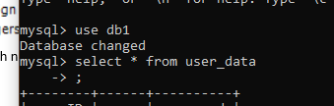

1. Accessing db1

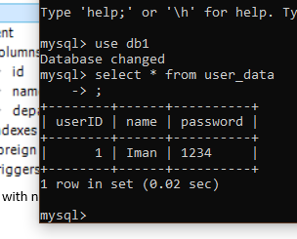

1. Database Records on user_data

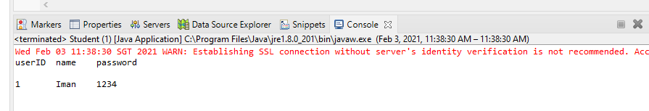

1. Run Student class to connect to Student.java